ALI ASKARI ZAIDI

SECTION A

1. **Create store procedure with no parameter**

Solution:

DELIMITER //



CREATE PROCEDURE displayRows()

BEGIN

SELECT * FROM employees;

END//

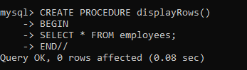

CALL displayRows()//

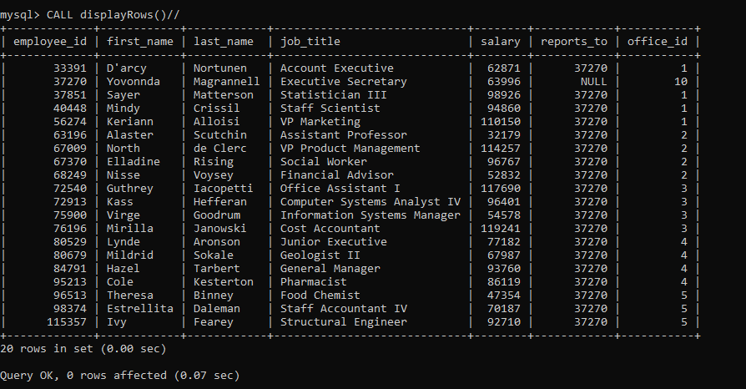

1. **Create store procedure with IN parameter (optional two or more parameters)**

Solution:

CREATE PROCEDURE fetchDataOfPerson(IN emp_id int, IN name varchar(255))

BEGIN

SELECT * FROM employees

WHERE employee_id=emp_id AND (first_name=name OR last_name=name);

END//

CALL fetchDataOfPerson(67009,'North')//

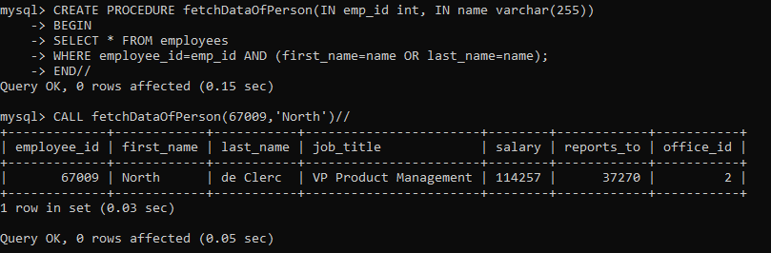

**3. Create store procedure with OUT parameter (optional two or more parameters)**

Solution:

CREATE PROCEDURE countPersonsAndAverageSalary(OUT numbers int, OUT avg_sal DECIMAL(8,2))

BEGIN

SELECT COUNT(employee_id) INTO numbers FROM employees;

SELECT AVG(salary) INTO avg_sal FROM employees;

END//

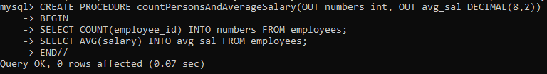

CALL countPersonsAndAverageSalary(@count_Persons, @average_Sal)//



SELECT @count_persons//

SELECT @average_sal//

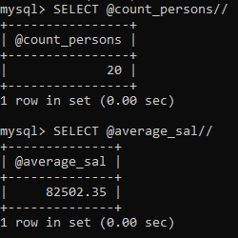

1. **Create store procedure with INOUT parameter ()**

Solution:

CREATE PROCEDURE updateSalary(INOUT sal INT(11))

BEGIN

SELECT employee_id,salary FROM employees

WHERE salary<sal;

SET sal=sal+10000;

END//

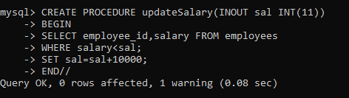

SET @sal=50000//

CALL updateSalary(@sal)

//

SELECT @sal

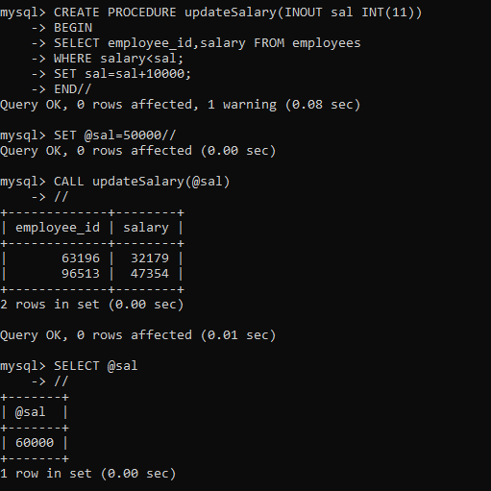

1. **USE IF ELSEIF, ELSE**

CREATE PROCEDURE SalaryStatus(IN emp_id INT, OUT sal_status VARCHAR(255))

BEGIN

DECLARE curr_sal DECIMAL(8,2);

DECLARE avrg_sal DECIMAL(8,2);

SELECT AVG(salary) INTO avrg_sal FROM employees;

SELECT salary INTO curr_sal FROM employees

WHERE emp_id=employee_id;

IF curr_sal < avrg_sal THEN

SET sal_status='Less than Average salary';

ELSEIF curr_sal=avrg_sal THEN

SET sal_status='Equal to average salary';

ELSEIF curr_sal>avrg_sal THEN

SET sal_status='Greater than average salary';

END IF;

END//

CALL SalaryStatus(75900,@sal_status)//

SELECT @sal_status//

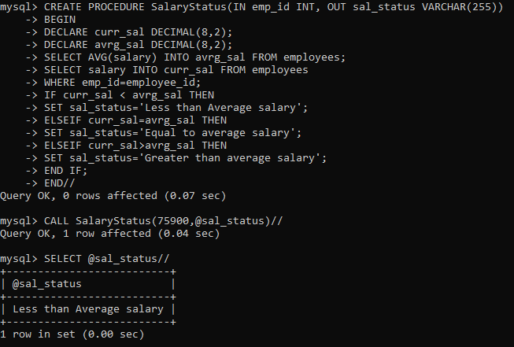

1. **Drop any one store procedure**

DROP PROCEDURE IF EXISTS SalaryStatus//

CALL SalaryStatus(75900,@sal_status)//

